Steps For Demo 1

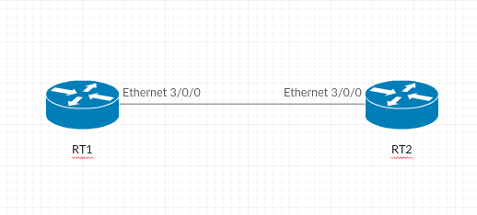

- Compile ONOS with buck build onos command.
- Bring up ONOS by using ok clean command.
- Start CLI by using onos localhost command.
- Activate Required appllications and run the curl command to swtich the Restconf to use YangRuntime.
- Pre-configure netconf configurations on the Device.
- Place netconf-cfg.json in path (@$ONOS_ROOT/tools/test/configs/)
- Send json to start the netconf connection with devices.
- Send Vrf-Lite configurations via json.
- Ping from RT1 to RT2.

